UNIT I WIND TUNNEL TESTING
Low-Speed Wind Tunnels
A general utility low-speed tunnel has four important components, namely, the effuser, the test-section, the diffuser, and the driving
Effuser
This is basically a contraction cone, Its application is to bring down the level of turbulence and increase the velocity of flow. The contraction ratio n of an effuser is defined as
n = Area at entry to convergent cone. Area at exit of convergent cone
The contraction ratio usually varies from 4 to 20 for conventional low-speed tunnels.
Test-Section
The portion of the tunnel with constant flow characteristics across its entire section is termed the test- or working-section. Because a boundary layer is formed along the test-section walls, the walls are given a suitable divergence so that the net cross-sectional area of the uniform flow is constant along the length of the test-section.
Diffuser
The purpose of the diffuser is to convert the kinetic energy of the flow coming out of the test-section to pressure energy, before it leaves the diffuser, as efficiently as possible. Generally, the smaller the diffuser divergence angle, the more efficient is the diffuser. Near the exit, its cross section should be circular to accommodate the fan.
Driving Unit
Generally the driving unit consists of a motor and a propeller or fan combination. The fan is used to increase the static pressure of the stream leaving the diffuser.
The wind tunnel fan, looking similar to the propeller of an airplane, operates under peculiar conditions that put it in a class by itself. Because the thrust of the fan and the drag of the various tunnel components vary with the square of the fan rpm, it would appear that to maintain a uniform velocity distribution in the test-section, speed adjustments should be made by varying the fan rpm rather than fan pitch. Although this conclusion is justified in short tunnels of low contraction ratio, for large tunnels it is not true. Indeed, many large tunnels that are equipped with both rpm and pitch change mechanisms use only the latter, being quick and simpler.
Power Losses in a Wind Tunnel
The total power loss in a wind tunnel may be split into the following components.
• Losses in cylindrical parts
• Losses in guide vanes at the corner (in closed circuit tunnels)
• Losses in diffuser
• Losses in contraction cone
• Losses in honeycomb, screens, and so on
• Losses in test-section (jet losses in case of open jet)
• Losses in exit in case of open circuit tunnel
Calculation of Percentage Energy Loss in the Various Parts of Wind Tunnel
The loss of energy is expressed in terms of static pressure drop 􏰃p, in the dimensionless form, called pressure drop coeffiicient K , as follows.

K = Δp/q
where q is the dynamic pressure of the flow. In terms of local velocity V,
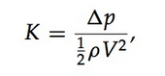
where ρ is the density of the flow. It is convenient to refer the local losses at different parts of the wind tunnel to the jet or test-section dynamic pressure, defining the coefficient of loss as
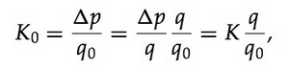
where q0 is the test-section dynamic pressure. But q ∝ V² and V ∝ 1/A ∝1/D², therefore, the above equation can be rewritten as
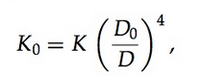

where D₀ is the test-section diameter and D is the local tunnel diameter. Using the above definitions, the section energy loss in the wind tunnel ΔEmay be expressed as
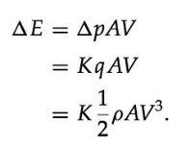
But K _{q} = K₀q₀, therefore, Eq. becomes
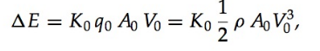
where A₀ is the test-section area and A is the local cross-sectional area. Note that in the above discussions on energy loss, the density of the flow is treated as invariant, even though it is valid only for incompressible flows. Such an assumption is usually made in the study of low-speed wind tunnels, because the Mach number involved is always less than 0.5, the compressibility effect associated with the flow is only marginal, and hence assuming the density ρ as an invariant will not introduce any significant error to the measured values.
Energy Ratio
The ratio of the energy of the airstream at the test-section to the input energy to the driving unit is a measure of the efficiency of a wind tunnel. It is nearly always greater than unity, indicating that the amount of stored energy in the wind stream is capable of doing work at a higher rate than what it is doing in a wind tunnel, before being brought to rest. The energy ratio ER is in the range
3 to 7, for most closed-throat wind tunnels. The energy ratio is defined as
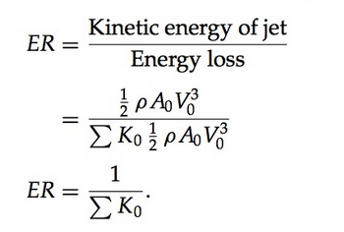
The definition of the energy ratio given by Eq excludes the fan and motor efficiency.
The magnitudes of the losses in the various components of a wind tunnel of circular cross section may be calculated as follows.
Losses in Cylindrical Section
We know that the pressure drop in a cylindrical section of length L can be expressed as
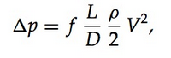

where f is the friction coefficient and D is the diameter of the cylindrical section.
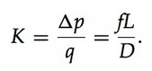
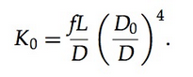
The value of the friction coefficient f may be computed from the Von Karman formula which gives
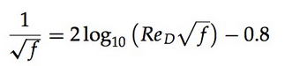

for smooth pipes at high Reynolds numbers. Some numerical values of f at specified Reynolds numbers are listed below. It is seen that f drops by only a factor of 5 over a 10,000-fold increase in Reynolds number. The above equation for f in terms of Re D is usually used for calculating f . There are many alternate approximations in the literature
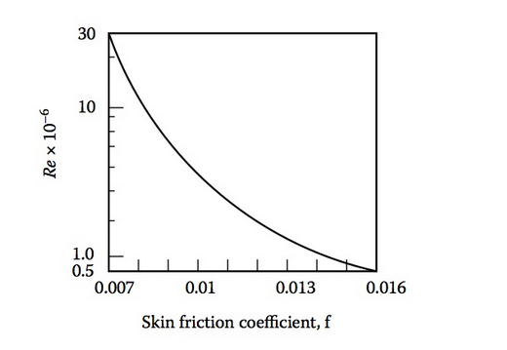

fromwhich f canbecomputedexplicitlyfromReD.However,forwindtunnel applications the above relation is good enough.
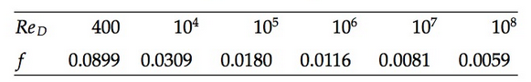

The friction coefficient variation with Reynolds number is shown, can be used to compute K0 for (i) the test-section and (ii) the return passage (where there is no divergence in the section). For cross sections other than circular, an equivalent diameter has to be used for the calculation of Re, f , and so on.

Losses in Convergent Cone
Consider the contraction cone, with diameters D1, and D0 at its entrance and exit, respectively. The loss in the convergent section is mainly due to friction. This loss may be expressed in terms of pressure loss as
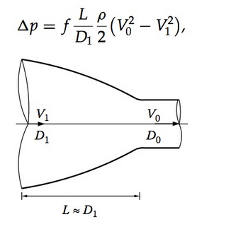

where V1 and V0 are the velocities at the inlet and exit of the convergent section, respectively.
Usually, for contraction cones L ≈ D1, therefore, Eq. becomes
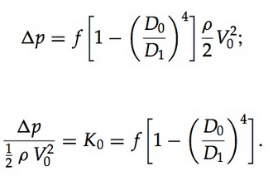

For contraction cones of good shapes with smooth walls, experimental results give f = 0.005, therefore,
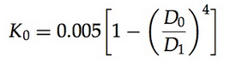
Losses in Diffuser
The loss of energy in the diffuser is due to (i) skin friction and (ii) expansion. Consider the divergent section shown in Figure 3.5, with V1, D1 and V2, D2 as the velocity and diameter at its entrance and exit, respectively.
Taking fn as the average value of the friction coefficient, the pressure loss in a divergent section may be expressed as
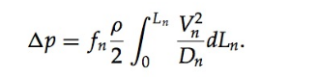
For an incompressible flow through the diffuser, by continuity, we have
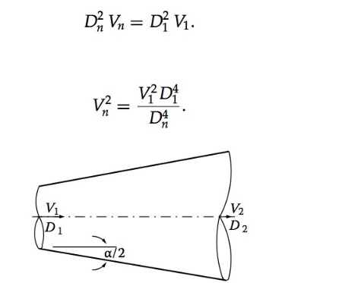

In the above equations the subscript n stands for conditions at the exit of the nth section of the diffuser. This implies that the diffuser may have n sections with different divergence angles α between the opposite walls. In the present case, the diffuser shown in Figure 3.5 has only one portion with divergence angle α, therefore, Dn = D2, Vn = V2.
Substituting the above expression for V2 into the 􏰃p equation above, we get
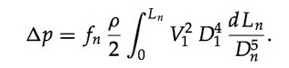
From the geometry of the diffuser shown in Figure 3.5, we have
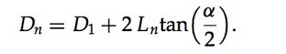

In the differential form, this becomes
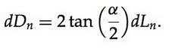
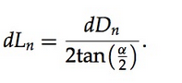
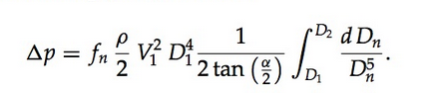

On integration, this yields
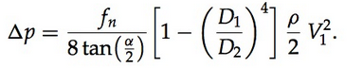
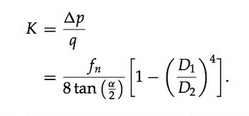
In terms of test-section dynamic pressure, the above equation becomes
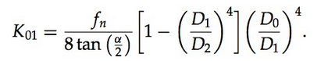
The expansion losses may be calculated from Fleigners formula, which expresses the pressure loss (except for tapered water pipe) as
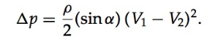

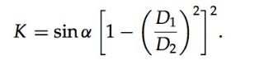

In terms of test-section dynamic pressure, the above K becomes
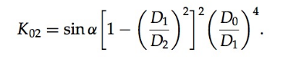
The total loss coefficient for the diffuser is the sum of frictional and expansion loss coefficients. Thus,
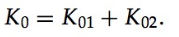

The variation of pressure loss coefficients K 01 , K 02 , and K 0 with diffuser divergence angle α is shown in Figure 3.6.
It is seen from Figure 3.6 that divergence angle α between 6 and 8 degrees proves to be the optimum for diffusers, resulting in minimum pressure loss.
Honeycombs
Wind tunnels have honeycombs in the settling chamber, in order to improve the flow quality in the test-section. Usually, the honeycombs are made of oc- tagonal, hexagonal, square, or circular cells with their length five to ten times their width (diameter). Some typical honeycombs used in wind tunnels are
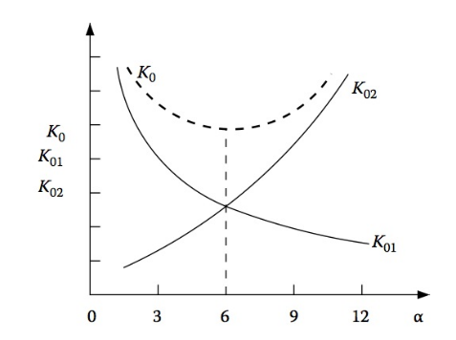
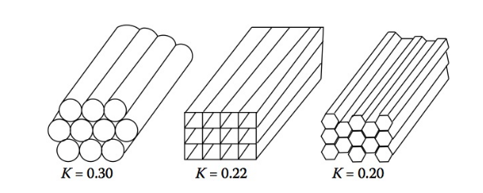
Honey combs

Guide Vanes
In wind tunnel design, it is not practical to make the corners of the return passage so gradual that the air can follow the corner walls with very small pressure loss. Such corners would require more space and more construction cost. Abrupt corners are therefore used, and their losses are kept to a minimum by means of corner or guide vanes. The losses in guide vanes are due to
• The skin friction of the vanes (approximately 33 percent of the total corner loss)
• Rotational component due to change of flow direction (rest of the corner loss)
Abrupt corners without guide vanes may show a loss of even 100 percent of velocity head. Well-designed corners with guide vanes can reduce the loss by 15 to 20 percent. Here, basically the corner is divided into many vanes of high aspect ratio, defined as the ratio of vane gap G to height h, as shown in Figure 3.8.

Commonly employed corner vanes have an aspect ratio of 6. In general, this criterion defines the vane gap because the height is known. Some typical vane profiles are shown in Figure 3.9, with the loss
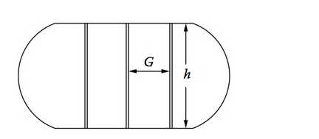

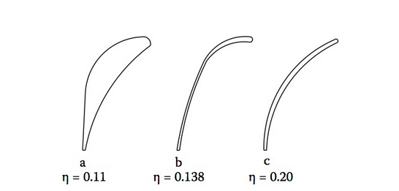

In the corners, friction in the guide vanes accounts for about one-third of the total corner loss, and rotation losses account for the other two-thirds. For guide vanes of the type shown in Figure 3.9, the pressure loss coefficient K0 may be calculated by the following formula, provided 􏰃p/q ≈ 0.15 based on Re = 500,000;
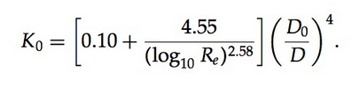
Losses Due to Open-Jet Test-Section
Consider the open-jet test-section, as shown in Figure 3.10. If the jet is assumed to be a closed jet, as shown by the dashed lines, the losses will become very small. For example, let the length of the jet be 1.5 times the diameter D0. For a smooth wall the friction coefficient is very low and is of the order 0.008. Treating the jet as a cylindrical portion, the loss becomes,
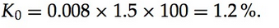
Instead, when the jet is open the coefficient of friction is approximately 0.08 and therefore,
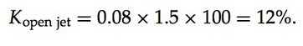

That is, the jet loss for a open test-section is approximately ten times that for a closed test-section. Furthermore, for open test-section operation, due consideration must be given to the possibility of pulsations similar to the vibrations in an organ pipe arising at the jet boundaries. This phenomenon, believed to be a function of jet length, can be quite serious. The simplest solution generally applied to overcome this problem is to provide vents in the diffuser, as shown in Figure 3.10, which connects it to the atmosphere. Such an arrangement is called a breather.
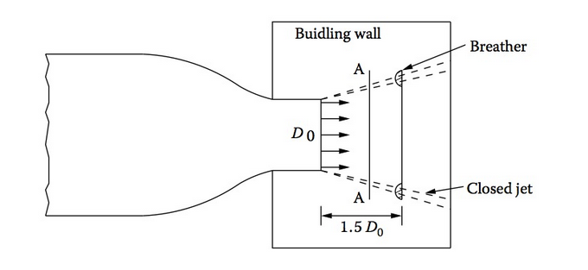
Open-jet test-section.

Supersonic wind tunnels:

In a blowdown tunnel circuit, the pressure and temperature of air in the com- pressed air reservoir (also called the storage tank) change during operation.
This change of reservoir pressure causes the following effects.
• The tunnel stagnation and settling chamber pressures fall corre- spondingly.
• The tunnel is subjected to dynamic condition.
• Dynamic pressure in the test-section falls and hence, the forces act- ing on the model change during the test.
• Reynolds number of the flow changes during the tunnel run.
Usually three methods of operation are adopted for blowdown tunnel operation. They are
• Constant Reynolds number operation • Constant pressure operation • Constant throttle operation
The ratio between the settling chamber initial pressure pbi and reservoir initial pressure p0i is an important parameter influencing the test-section Reynolds number. Let
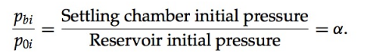
The variation of Reynolds number with tunnel running time t, as a function of α is as shown in Figure 3.19.
As seen in Figure 3.19, the Reynolds number increases with running time for constant pressure operation, and decreases with running time for constant throttle operation. The change in Reynolds number results in the change of boundary layer thickness, which in turn causes area and Mach number change in the test-section. Usually Mach number variation due to the above causes is small.
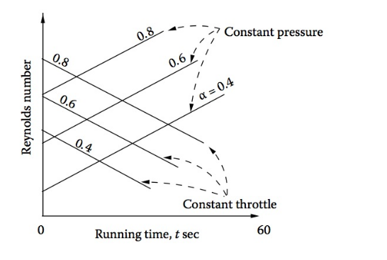

Running Time of Blowdown Wind Tunnels
Blowdown supersonic wind tunnels are usually operated with either constant dynamic pressure (q ) or constant mass flow rate (m ̇ ).
For constant q operation, the only control necessary is a pressure- regulating valve (PRV) that holds the stagnation pressure in the settling chamber at a constant value. The stagnation pressure in the storage tank falls according to the polytropic process: with the polytropic index n = 1.4 for short duration runs, with high mass flow, approaching n = 1.0 for long duration runs with thermal mass1 in the tank.
For constant mass flow run, the stagnation temperature and pressure in the settling chamber must be held constant. For this, either a heater or a thermal mass external to the storage tank is essential. The addition of heat energy to the pressure energy in the storage tank results in longer running time of the tunnel. Another important consequence of this heat addition is that the constant settling chamber temperature of the constant mass run keeps the test-section Reynolds number at a constant value.
For calculating the running time of a tunnel, we make the following assumptions.
• Expansion of the gas in the storage tank is polytropic.
• Gas temperature in the storage tank is held constant with a heater.
• Gas pressure in the settling chamber is kept constant with a pressure- regulating valve.
• No heat is lost in the pipelines from the storage tank to the test- section.
• Expansion of the gas from the settling chamber to the test-section is isentropic.
• Test-section speed is supersonic.
The mass flow rate m ̇ through the tunnel,
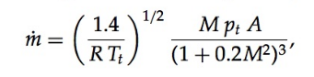

where M is the test-section Mach number, and pt and Tt , respectively, are the pressure and temperature in the settling chamber.
We know that for supersonic flows it is convenient to calculate the mass flow rate with nozzle throat conditions. At the throat, M = 1.0
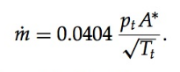

The value of the gas constant used in the above equation is R = 287 m²/(s² K), which is the gas constant for air. The product of mass flow rate and runtime gives the change of mass in the storage tank. Therefore,
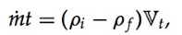
where V_{t} is the tank volume and ρi and ρ f are the initial and final densities in the tank, respectively.
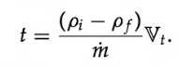
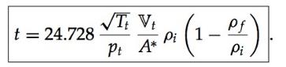

For polytropic expansion of air in the storage tank, we can write
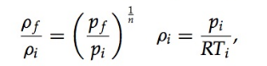
where subscripts i and f denote the initial and final conditions in the tank, respectively.
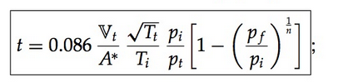
with V_{t} in m³; this gives the runtime in seconds for the general case of blow- down tunnel operation with constant mass flow rate condition.
From Eq. (3.42) it is obvious that for t_{max} the condition required is p_{t} minimum. At this stage we should realize that the above equation for running time has to be approached from a practical point of view and not from a purely mathematical point of view. Realizing this, it can be seen that the
tunnel run does not continue until the tank pressure drops to the settling chamber stagnation pressure pt , but stops when the storage pressure reaches a value that is appreciably higher than p_{t} ,that is, when p_{f} =p_{t}+Δp. This Δp is required to overcome the frictional and other losses in the piping system between the storage tank and the settling chamber. The value of 􏰃p varies from about 0.1pt for very-small-mass flow runs to somewhere around 1.0pt for high-mass flow runs.
The proper value of the poly-tropic index n in Eq. (3.42) depends on the rate at which the stored high-pressure air is used, total amount of air used, and the shape of the storage tank. The value of n tends toward 1.4 as the storage tank shape approaches a spherical shape. With heat storage material in the tank (i.e., for isothermal conditions), the index n approaches unity. Equation (3.42) may also be used with reasonable accuracy for constant pressure runs in which the change in total temperature is small, because these runs approach the constant mass flow rate situation.

