UNIT 2 EXPERIMENTS IN SUBSONIC WIND TUNNELS
C_{l} and C_{d} on Aerofoils:

Some basic concepts of subsonic flow are demonstrated using a nominal 50 m/s wind tunnel. The section-lift and drag coefficients for a symmetric airfoil are obtained by analyzing the measured pressure distributions at several pressure taps on the airfoil surface. Some observations are also made for the airfoil pitching motion and for small perturbations. The airfoil spans the tunnel test section. A multi-tube water manometer board is used to monitor the surface pressures and provide a visual display of the dynamic changes associated with varying angle of attack. A computer-aided data acquisition system is used to collect and record pressure data from the pressure probes.
The major elements of the open-loop subsonic wind tunnel facility are indicated in Fig. The tunnel operates as open circuit, meaning air is drawn from the laboratory and also exhausted to the laboratory.

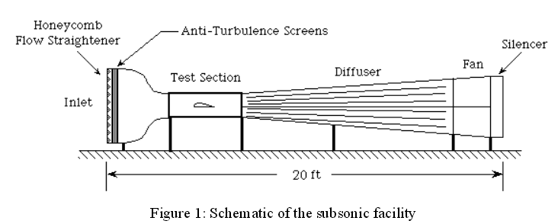
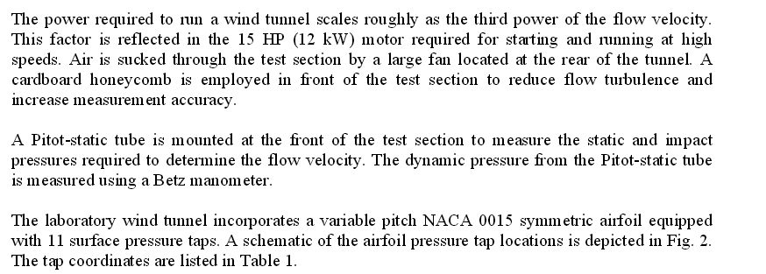
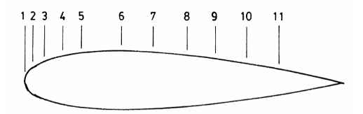

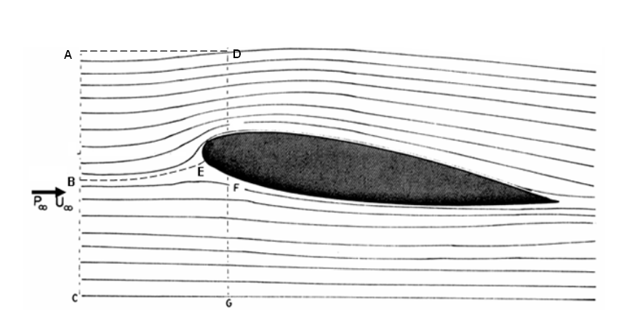
Streamlines around an airfoil in an incompressible flow

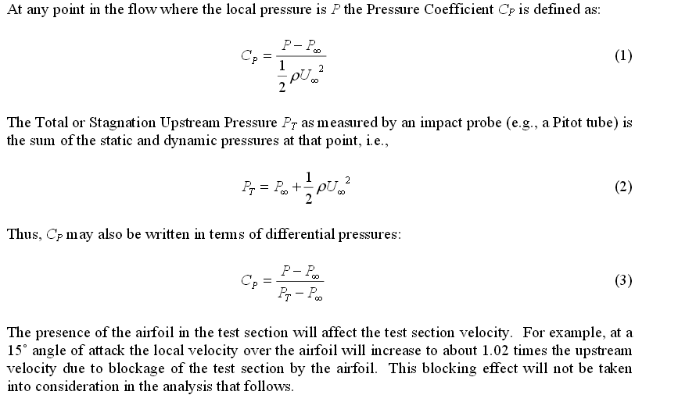
Lift and Pressure Drag
The normal pressure force Pds, acting on a small region, may be resolved into components dX and dZ acting parallel and perpendicular to the chord, respectively
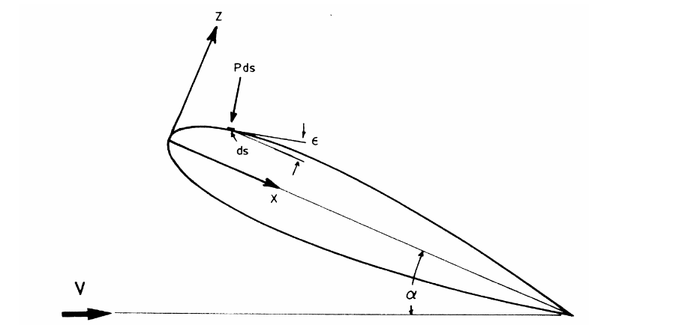
Normal pressure force on an airfoil surface

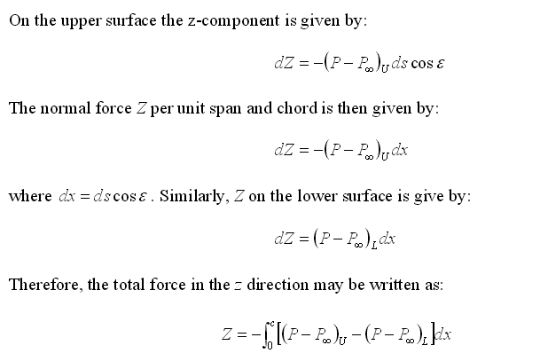
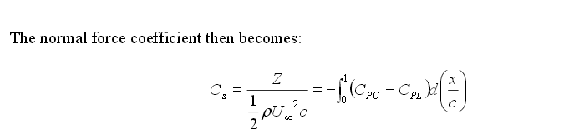
Pressure Drag
The force coefficient parallel to the chord is responsible for pressure drag on the airfoil, and this coefficient may be derived in a manner similar to that previously employed for the normal pressure force. First, divide the airfoil into 2 sections, fore and aft, such that fore is the area in front of the maximum thickness point of the airfoil as indicated in Fig
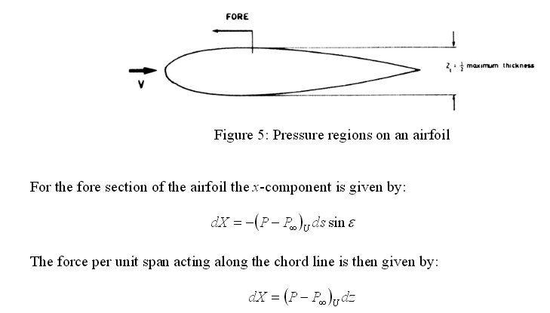
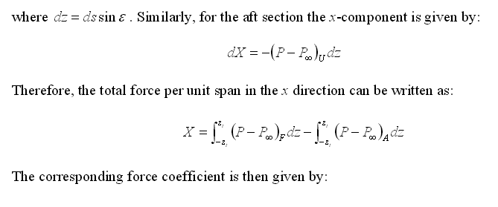
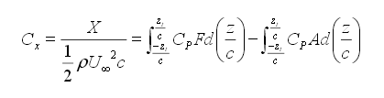
Lift and Drag Coefficients
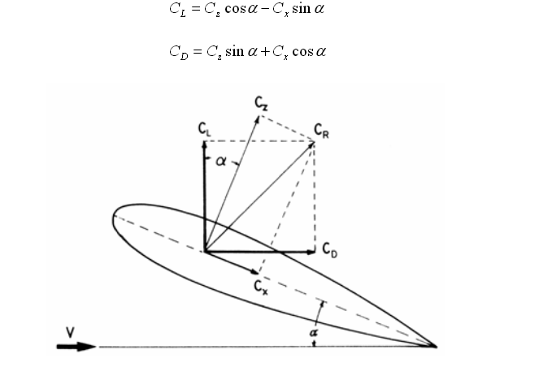
Component for diagram

C_{d} from wake survey:
Drag estimation by wake survey is a experimental technique specially useful for measuring the drag of airfoils at low angles of attack, since the low drag present in such situations may be difficult to measure with balances designed for measuring higher loads associated with the stalled aerofoil. The technique is based on the balance of the momentum in the free-stream direction performed over a control volume that encircles the airfoil, and is developed essentially for two-dimensional flows. Although far from the airfoil the static pressures are equal to that of
the free-stream and the wake velocity profile would be sufficient for the drag estimation, so far from the airfoil the uncertainty in the momentum deficit calculation that will lead to the drag may become too high. In the present work, using theoretical considerations and experimental results (obtained using PIV and simple Pitot-static tube measurements) attention is called to the difficulties of the drag estimation by wake survey based purely on velocities measurement and to the advantages of the technique based on dynamic and static pressures measurement.
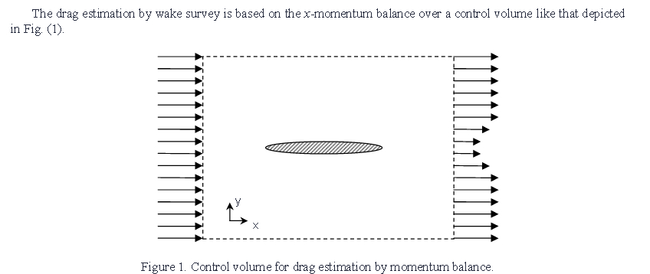

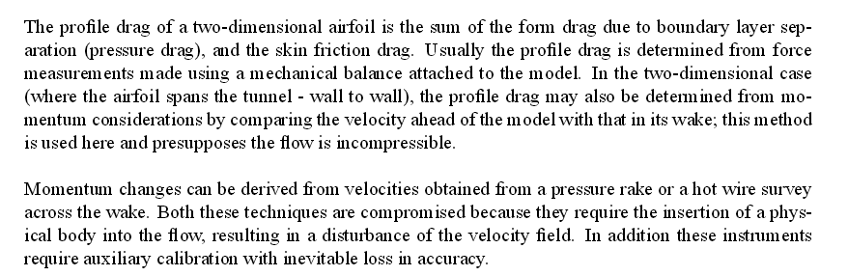

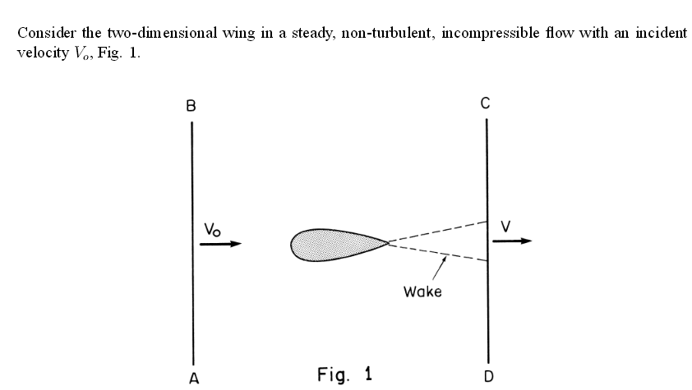
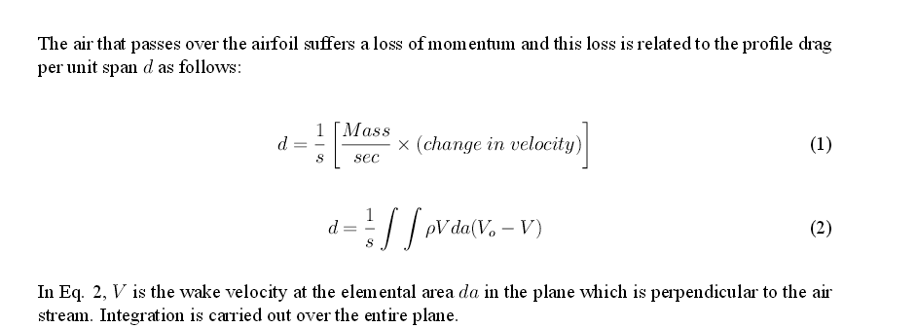
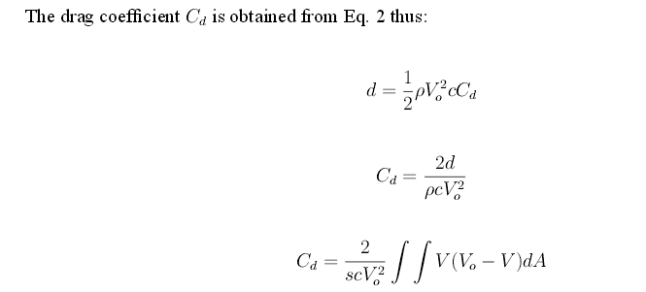
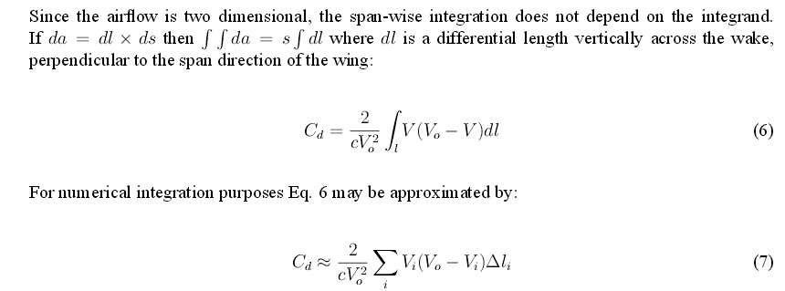

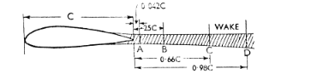
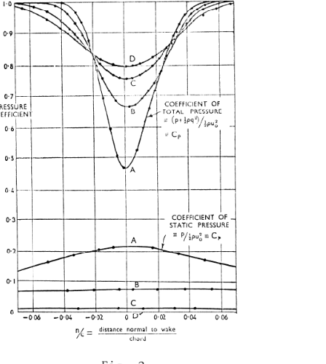
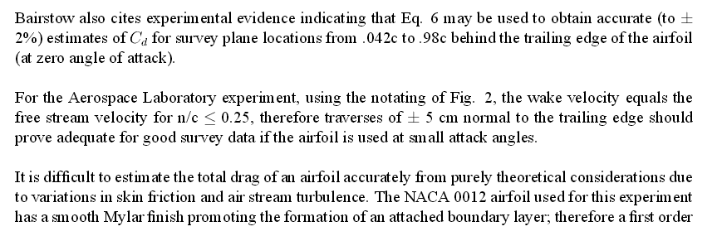
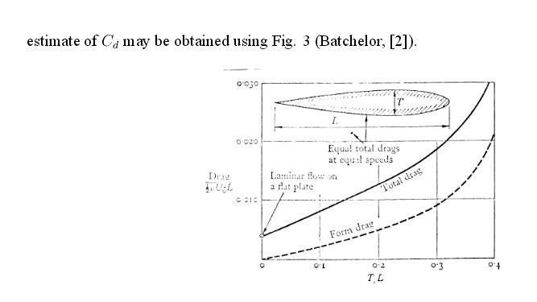

Test section Average velocity:
Connect your pressure transducer to the computer in the wind tunnel room (S&E N007) using the data acquisition system.
•Setup the data acquisition software to take 100 measurements at a rate of 10 readings per second.
•Mount the pitot probe in the wind tunnel as shown in Figure 1. Make sure that the pitot probe is lined up with the flow direction.
•Connect the stagnation pressure probe to the high side of your transducer. Connect the static pressure probe to the low side.

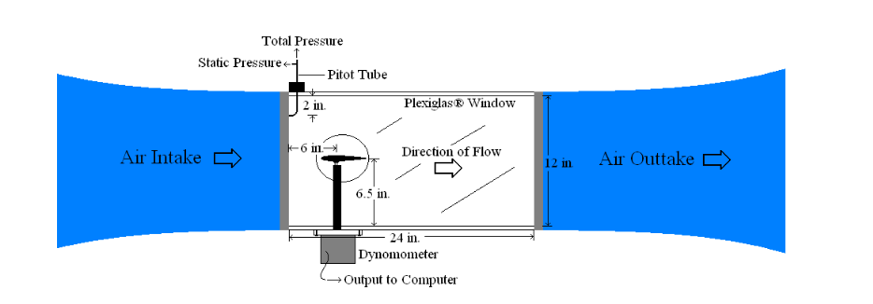
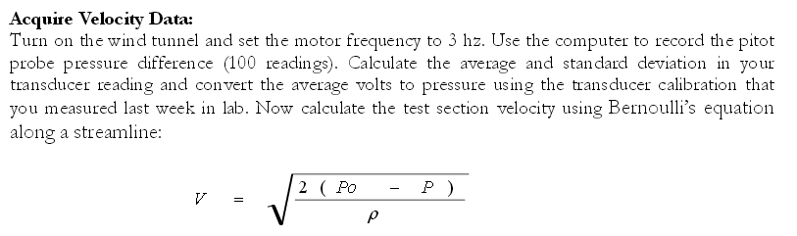
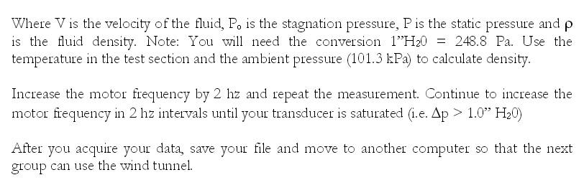
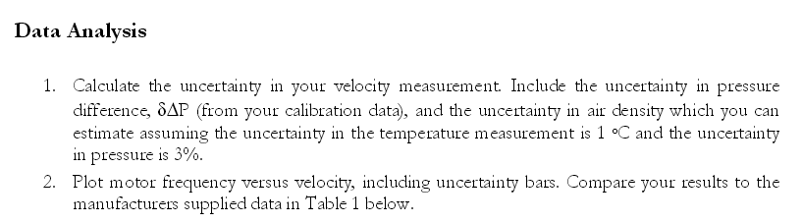

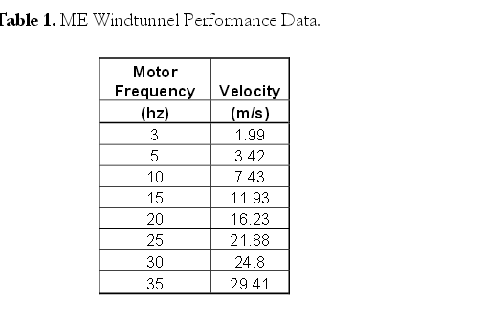

Span-wise Load distribution on tapered wings:
The aerodynamicist is usually concerned with properties, which affect the performance, stability and control of the airplane.
The stress analyst is concerned with the load distribution which will represent the most sever conditions for various parts of the internal structure of the airplane. Exact equations for span-wise lift distribution which can be found in many aerodynamic books, can be solved for many wing planform. Analytical and numerical methods to solve these equations are available but the calculation is not simple. Approximation methods to find span-wise lift distribution are Simpler and available .
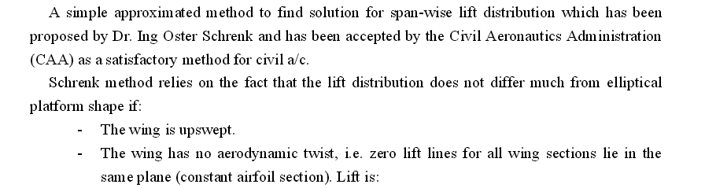
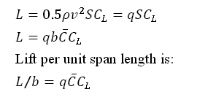
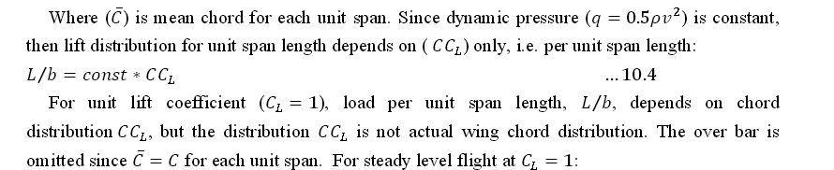
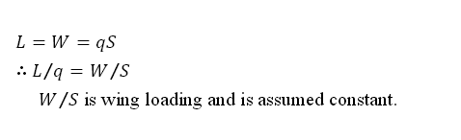
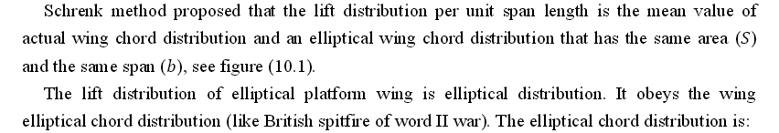
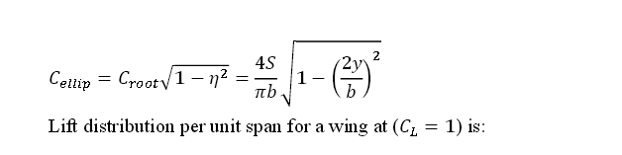

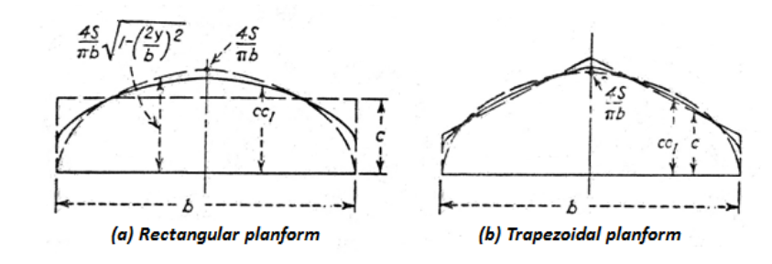
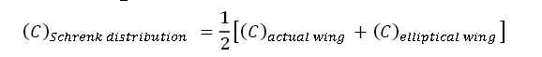
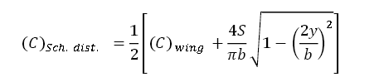
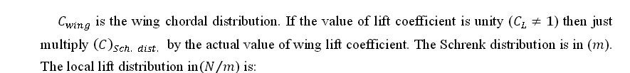
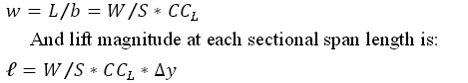
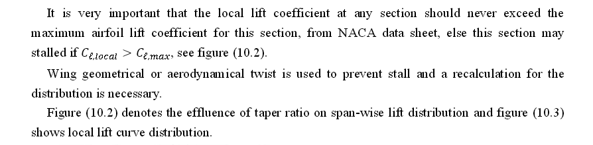
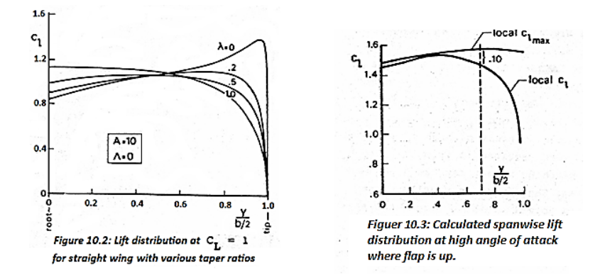

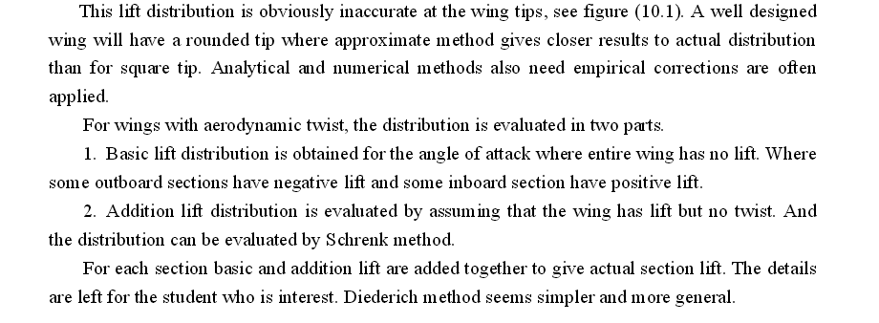

Shear force and Bending moment Distribution:
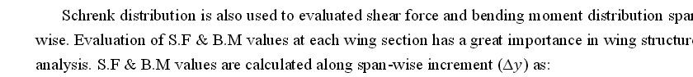

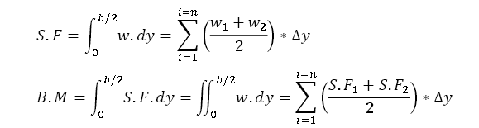

Flow angularity and Turbulence factor:

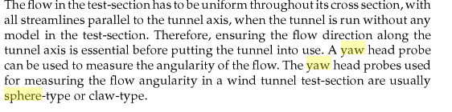
Yaw sphere:
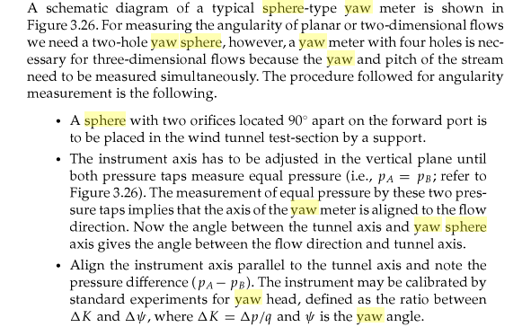
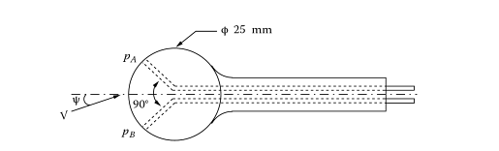
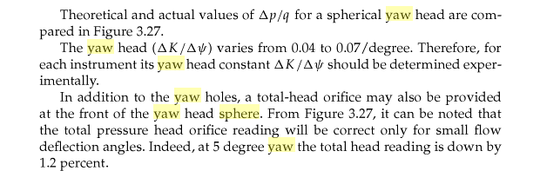

Claw-yaw meter:
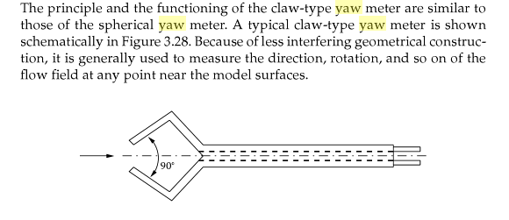

Turbulence:
The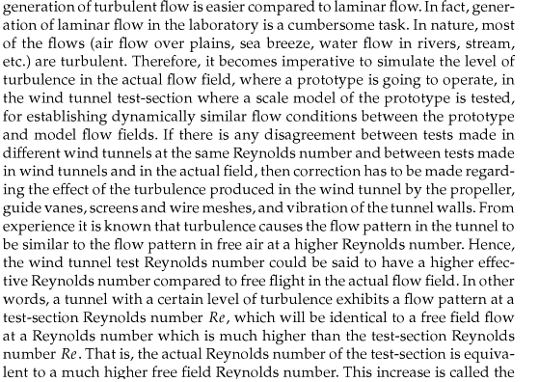
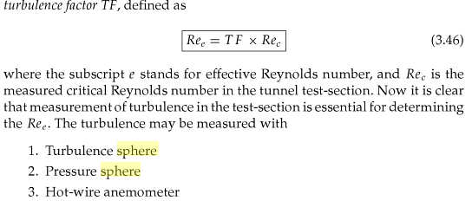
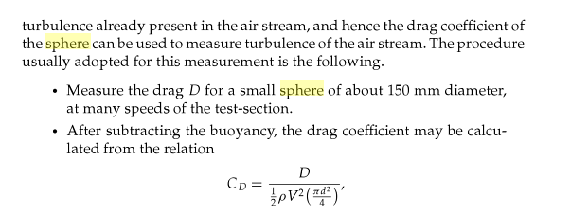
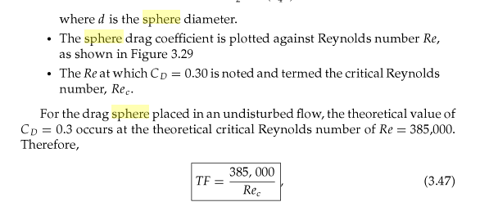
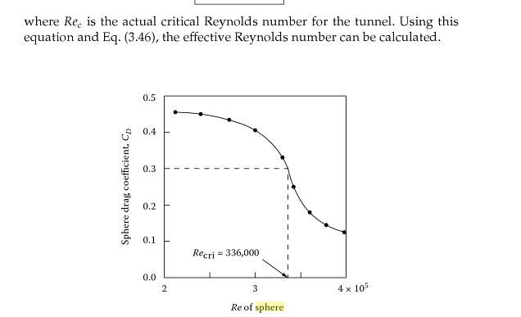

Pressure sphere:
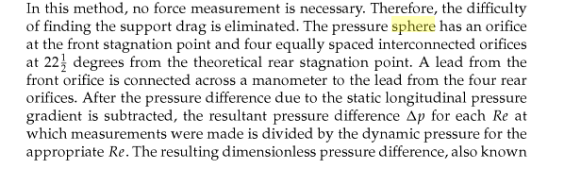
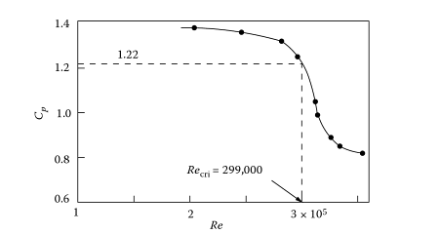

Hot wire anemometer:
