Unit 5 SPECIAL PROBLEMS
Pitot static correction for subsonic and supersonic mach numbers
It is well known that the measurement of both total and static pressure is essential to analyze fluid flows. The flow velocity can be determined using Bernoulli’s equation, if these two pressures are known. Also, we know that both incompressible and compressible forms of the Bernoulli equation are simply relations among the total pressure, static pressure, and flow velocity

Now, let us see some of the popular probes used for measuring these pressures.
From our basic studies on fluid mechanics we know that pitot or total pressure is that pressure which results when a fluid stream is brought to rest isentropically. Also, measurements of total pressure are relatively easier than the static pressure. When a body is placed in a fluid stream and if it is pos- sible to locate the exact point on it where the fluid is brought to rest then the pressure acting at that point will be the total pressure. Hence, this pres- sure can be measured by providing an orifice at that point and connecting it to a manometer. This forms the basis for a pitot or total tube, which is the most popular instrument used for total pressure measurement. It is an exper- imentally established fact that the pressure indicated by a properly aligned open-ended tube facing a flow is exactly equal to the local total pressure, except for viscous effects at very low Reynolds numbers and for supersonic flows where there will be a detached shock positioned ahead of the tube.
Measurement of static pressure requires more attention than the pitot pres- sure measurement. In principle, for measuring static pressure with a probe placed in a flow, the static holes should be drilled at the location where the local pressure is the same as that of freestream static pressure upstream of the probe nose. In reality this condition cannot be achieved exactly, due to the pressure gradients caused by the presence of the probe.
A pitot-static tube is used for measuring the total and static pressures si- multaneously. It is usually a blunt-nosed tube with an opening at its nose to sense the total pressure and a set of holes on the surface of the tube to sense the static pressure. Pitot, static, and pitot-static probes made based on the above basic principles are used extensively in experimental measure- ments. However, it is essential that a researcher uses discretion in applying the appropriate correction to the measured pressure to account for the errors due to compressibility, viscosity, misalignment, and so on.
Dynamic Head Measurement
In any flow field, basically there are three pressures of interest to gas dynamics studies. However, in fluid mechanics, we use yet a fourth one in parallel flow studies, which is termed geometric pressure. This pressure is due only to the gravitational action on a static fluid having the same geometry as the actual flow.
The three pressures of primary interest in fluid dynamics are the total or pitot, static, and dynamic pressures. We saw that the total pressure is that which results when a flow is decelerated to rest isentropically. From this we can infer that at a position in a flow where the flow velocity is zero, the total pressure and the undisturbed static pressure are identical.
The static pressure is that pressure which acts equally in all directions. The third pressure, namely the dynamic pressure, can be associated with the flow conditions at a point (say the Mach number) by taking the difference between the stagnation pressure and undisturbed static pressure.

In modern terminology yet another term, namely, velocity pressure, is used. It is simply half of the product of the fluid density and the square of the speed; also termed kinetic pressure. In incompressible flow it is simply the difference between total and static pressures.

For incompressible flows, the total, static, and dynamic pressures are linked together by Bernoulli’s s equation as
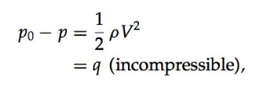

In any flow the total pressure will be the same everywhere when there are no losses. It is seen from the above equation that an increase of flow velocity results in a decrease of static pressure and vice versa. The dynamic pressure q is linked to the kinetic energy of the flow and it has the same direction as that of the flow. Also, we know that the static pressure of a flow is that pressure which is acting normal to the flow direction. Therefore, it follows from Bernoulli’s equation that the total pressure also has a definite direction. Total pressure, as we have seen, is measured by a simple device called a pitot (total) probe. A pitot probe is simply a tube with a blunt-nosed open end facing the gas stream. The tube normally has an inside-to-outside diameter ratio of 1/2 or 3/4, and a length aligned with the gas stream of 15 to 20 tube outer diameters. The pressure hole is formed by the inside diameter of the tube at the blunt end, facing the flow. A typical pitot probe is shown in Figure.
The open-ended tube facing into the flow always measures the stagnation pressure it sees, in subsonic flows. But at supersonic speeds there will be a detached shock formed and positioned in front of the pitot probe nose. It implies that the tube does not measure the actual stagnation pressure but only measures the stagnation pressure behind a normal shock. This new value is called pitot pressure and in modern terminology it refers to a supersonic stream.
This indicated pitot pressure p₀₂, the total pressure behind the normal shock, may be used for calculating the stream Mach number, as follows. For a supersonic stream with Mach number M1, and p₁ and p₀₁ as the static and stagnation pressures, respectively, by isentropic and normal shock relations, we have
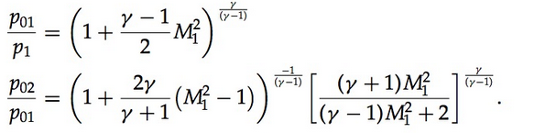

Multiplying these two equations, we obtain,
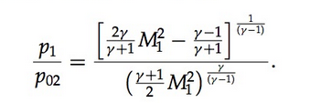

This relation is known as the Rayleigh supersonic pitot formula. Once the static pressure p1 and pitot pressure p02 are known, M1 can be calculated using this formula.
For a compressible flow, the pressures and the velocity are related by the equation
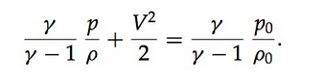
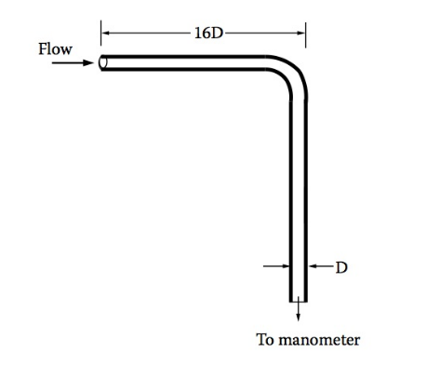
Pressures measured by pitot probes are significantly influenced by very low Reynolds numbers based on probe diameter. However, this effect is seldom a problem in supersonic streams because a probe of reasonable size will usually have a Reynolds number well above 500, which is above the range of troublesome Reynolds numbers.
Measurement of static pressure in a supersonic flow is more difficult than in a subsonic flow. Although static pressure probes are not used extensively in supersonic flows, a good amount of study has been done for the development of accurate pressure probes for other applications. The major problem associated with the use of static pressure probes at supersonic speeds is that the probe will have a shock wave at its nose which will cause a “jump” in static pressure.
Now, let us see the measurement of static pressure in subsonic flows. If the probe has a conical nose tip followed by a cylindrical stem shoulder, the flow passing the shoulder will be accelerated to a pressure below the freestream static pressure. However, as the distance from the nose increases, the pressure on the probe will approach the true static pressure of the stream. The sharp-nosed tip of the probe facing the flow is closed and static pressure holes are drilled perpendicular to the tube axis at a specified distance from the nose. The included angle of the nose cone should be small for good results. Also, it is well established that a static pressure hole located beyond eight times the outer diameter (8D) of the probe, from the nose, is good enough for reasonably accurate measurements. A typical L-shaped static probe is shown in Figure.
Static pressure measurements are very sensitive to the inclination of the tube to the flow direction. Inclinations beyond 5◦ result in large errors in the measured pressures. In order to minimize these errors, it is a common practice to have static probes with four holes in mutually perpendicular directions. In subsonic streams, when a static pressure probe is placed in the flow field, flow is accelerated because of the horizontal portion of the probe and decelerated because of the vertical stem. Therefore, the static pressure holes have to be located at such a location that these effects cancel each other and the probe measures the correct pressure. Such an appropriate location found by experimental research is about 8D, from the probe nose, as shown in Figure.
For measurement of static pressures in supersonic flow, the static pressure hole should be located beyond 18D from the nose and the velocity change associated with the presence of the probe should be kept to a minimum. For this the nose should be very sharp with an included angle less than 10◦. Also, it is usual practice to employ a straight probe (without vertical stem) for static pressure measurements in supersonic wind tunnels. The tip of the probe should be located at a subsonic zone of the flow field (for instance, upstream of the throat in a Laval nozzle) and hence there will be no formation of shock because of the probe presence.
The dynamic pressure of a flow can be measured directly by a special probe called a pitot-static probe, which is the combination of pitot and static probes. A typical pitot-static probe is shown in Figure
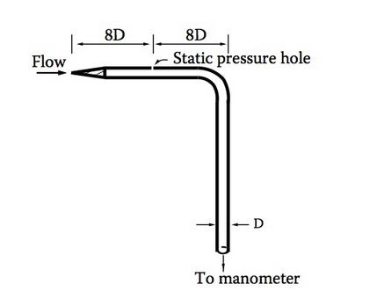

Boundary Layer velocity profile on a flat plate by momentum integral:
The basic equation for this method is obtained by integrating the x direction momentum equation (boundary layer momentum equation) with respect to y from the wall (at y = 0) to a distance which is assumed to be outside the boundary layer. Using this notation, we can rewrite the Karman momentum integral equation as

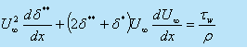
• The effect of pressure gradient is described by the second term on the left hand side. For pressure gradient surfaces in external flow or for the developing sections in internal flow, this term contributes to the pressure gradient.
• We assume a velocity profile which is a polynomial of . being a form of similarity variable , implies that with the growth of boundary layer as distance x varies from the leading edge, the velocity profile remains geometrically similar.
• We choose a velocity profile in the form
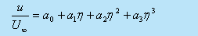
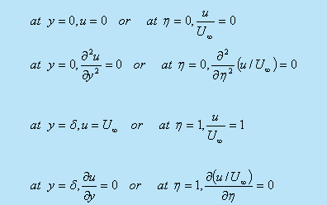
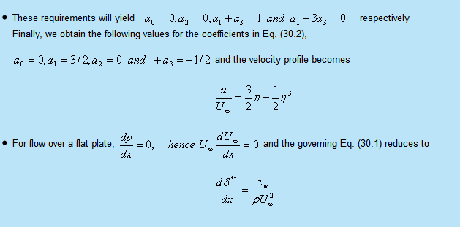

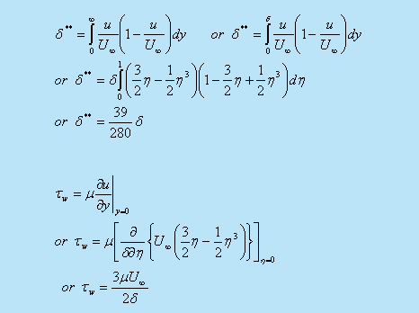
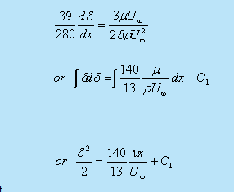

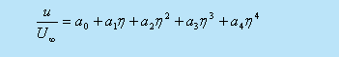

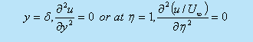
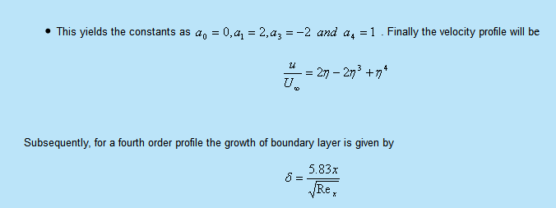

Heating Requirements in Hypersonic Wind tunnels:
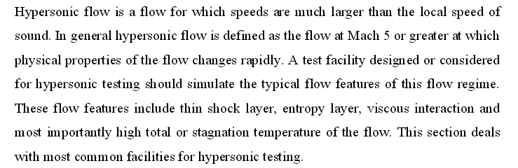
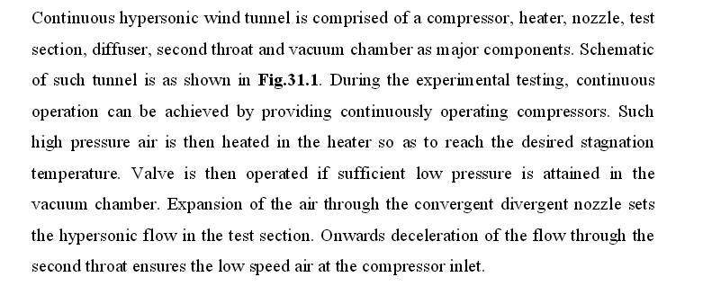
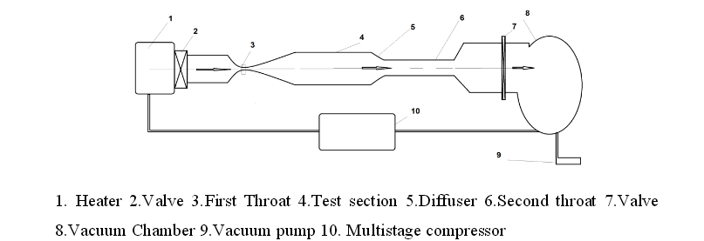
Heaters

Hypersonic Nozzles:
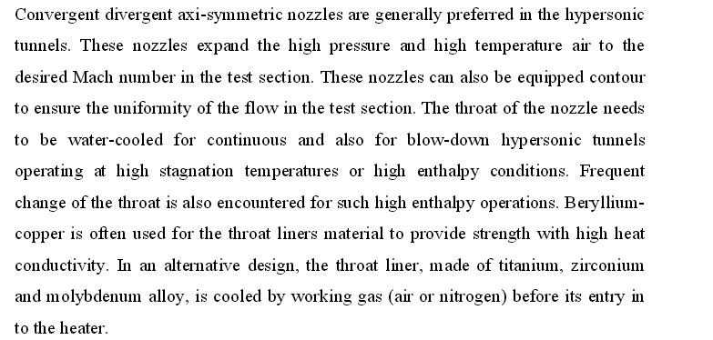
Hypersonic Diffuser
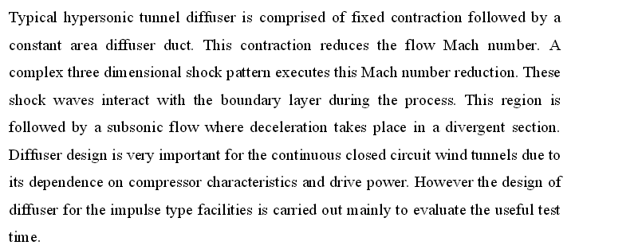
Blow-down Hypersonic Wind Tunnel
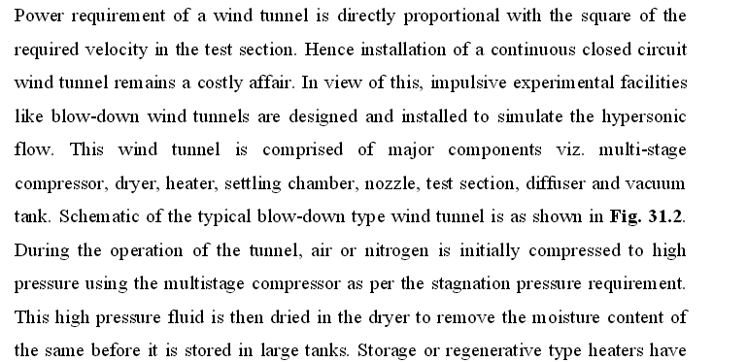
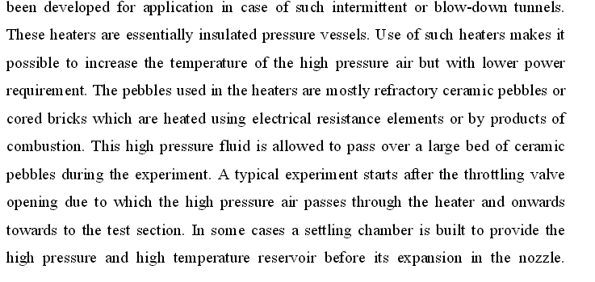
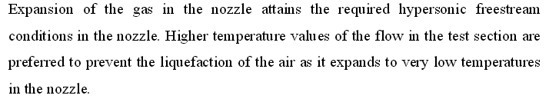
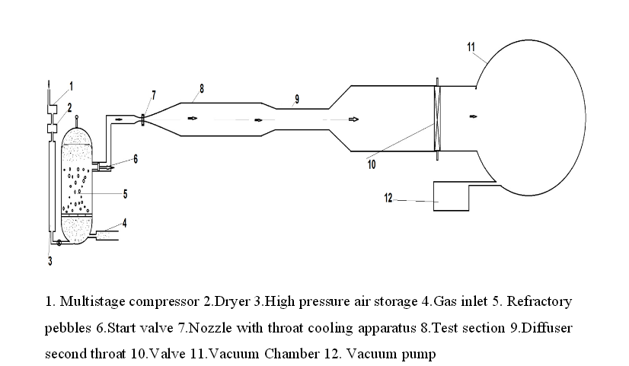

Measurement of wall shear stress:
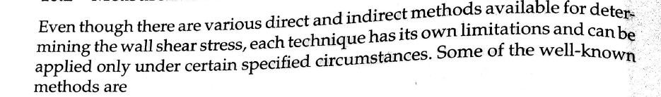
-Floating element method
-fence technique
Floating Element method:
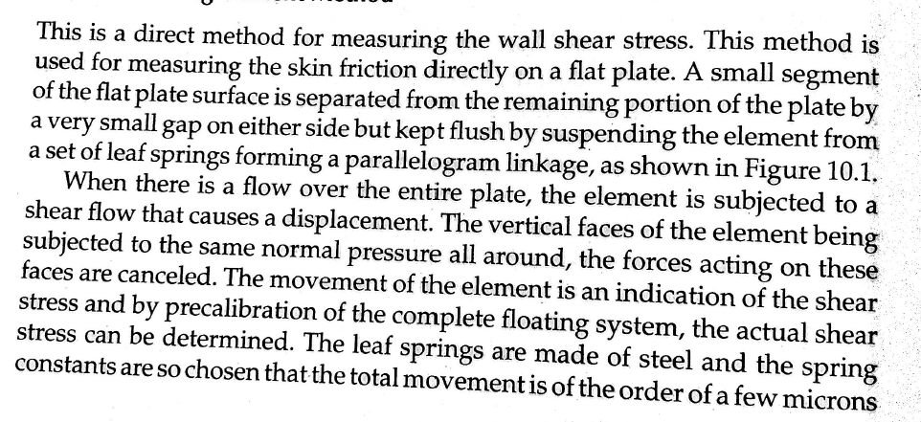
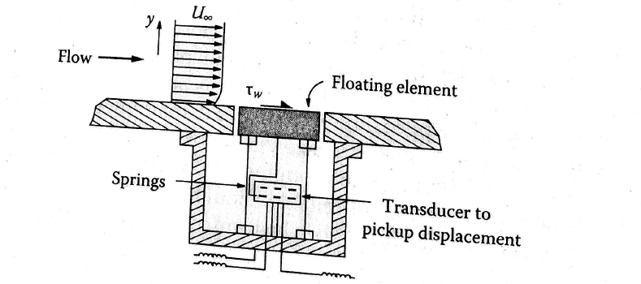

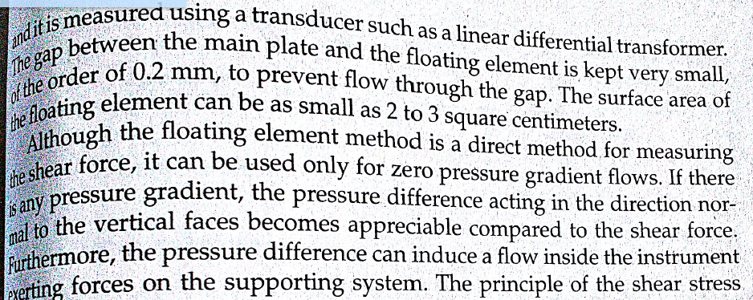
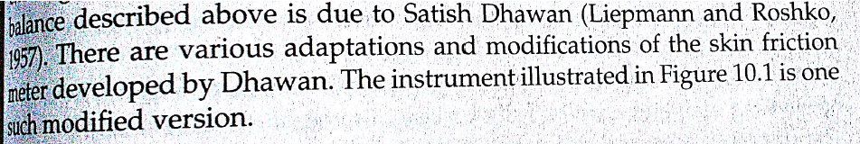

Fence Technique:
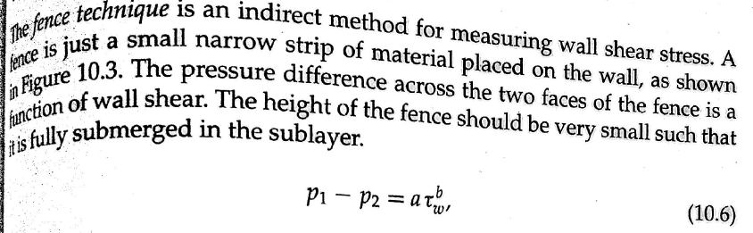
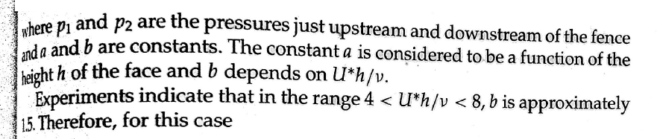
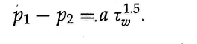
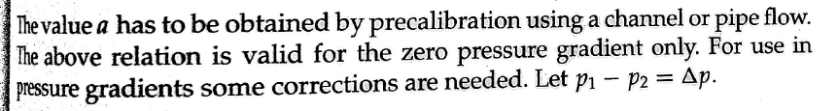
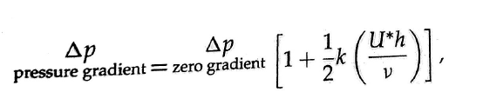
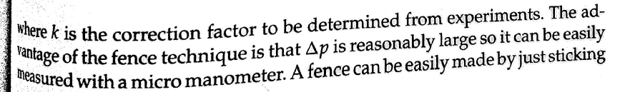
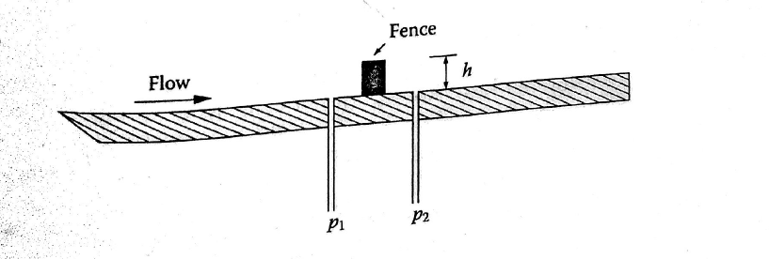
Law of the wall:
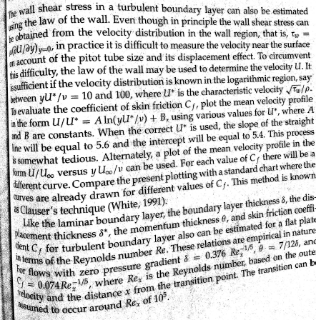
Therefore, C_{d}=2dθ/dx

